Mechatronics System Integration (MCTA3203)
Week 6: Smart Surveillance Camera using ESP32-CAM

Building a smart surveillance camera using ESP32-CAM

Overview
This module explores the integration of Internet of Things (IoT) and mechatronic actuators through the development of a smart surveillance system using the ESP32-CAM. Students will implement live video streaming over Wi-Fi and utilize Pulse Width Modulation (PWM) to control a servo motor for horizontal panning, simulating active motion tracking. This exercise provides a practical foundation in wireless data transmission and the synchronization of software with physical movement.
The system serves as an expandable platform, allowing for the integration of manual triggers or Passive Infrared (PIR) sensors to enable automated motion detection. By constructing this surveillance prototype, students demonstrate core mechatronic concepts, including sensor fusion and real-time hardware response. The lab bridges the gap between digital signal processing and physical system automation in a security context.
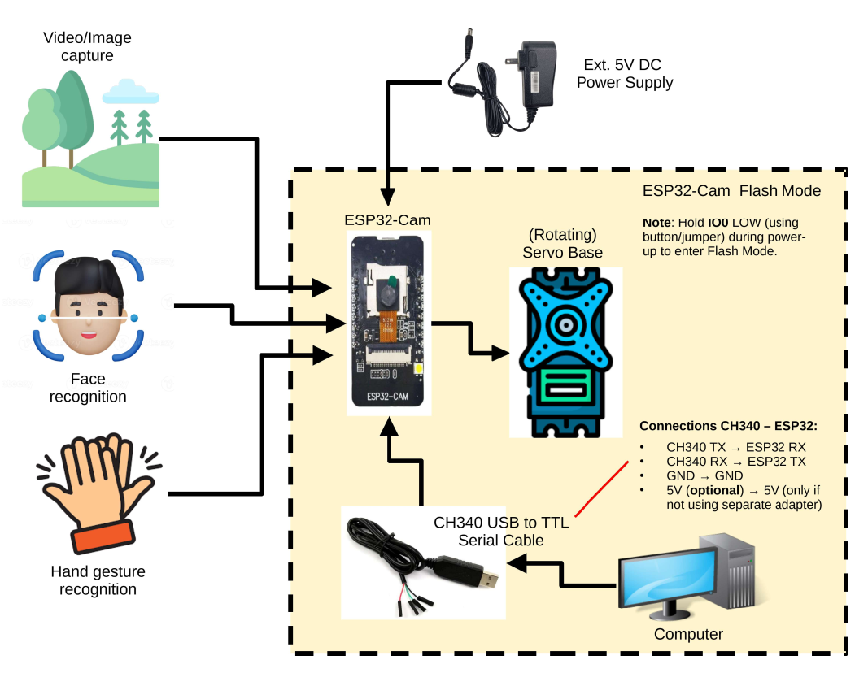
Figure 1 shows the system overview

Objectives
By the end of this lab, students will be able to:
- Interface and stream live video using the ESP32-CAM module.
- Control a servo motor for horizontal camera panning.
- Understand the integration of microcontroller, sensors, actuators, and wireless communication in mechatronic systems.

1. Required Hardware
- ESP32-CAM Module version OV2640
- CH340 USB to TTL Serial Cable or Micro-USB Cable or FTDI Cable
- Servo Motor
- Pushbutton
- 5V Power Supply (2A) or Powerbank (5V 2A)
- Jumper wires
- Breadboard
2. Theory
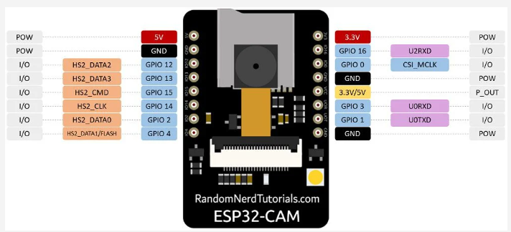

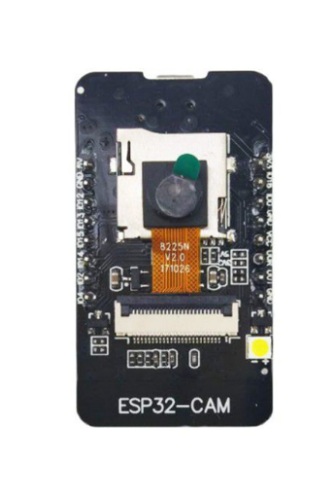
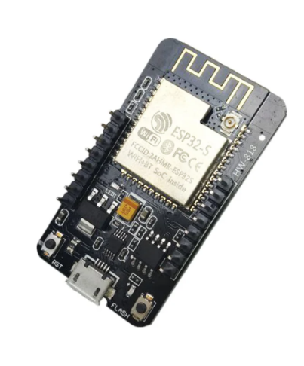

Figure 2 showing the pin configuration located on Cytron Technologies

3. Circuit diagram

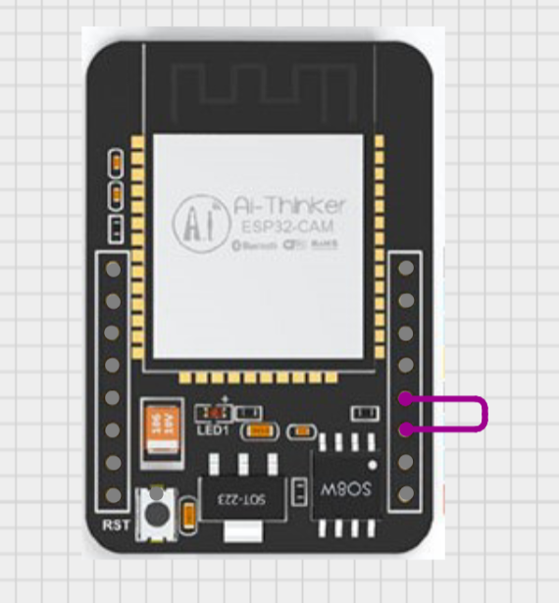
Figure 2 shows the pictures of the ESP32-CAM connection from GND to I0 pin

Below are three methods to program the ESP32-CAM with Arduino IDE;
- ESP32-CAM to FTDI
ESP32-CAM Pin | FTDI Pin
U0T | RX
U0R | TX
5V | 5V
GND | GND
IO0 | GND (Only during upload)

- ESP32-CAM to CH340 USB to TTL Serial Cable

ESP32-CAM Pin | CH340 Cable Wire
5V | Red (VCC)
GND | Black (GND)
U0R (GPIO3) | White (TXD)
U0T (GPIO1) | Green (RXD)

- Micro-USB Cable
Remember to also connect the I0 pin of the ESP32-CAM to GND bridging it during uploading command.

Pre-Lab Task
- Install Arduino IDE
- Go to the File menu, then select Preferences. Add the new preference to the Additional board manager URLs.
https://raw.githubusercontent.com/espressif/arduino-esp32/gh-pages/package_esp32_index.json
- Download the ESP32 version 2.0.14 ( by Espressif systems) from the board manager located on the left side of the IDE
- Download the ESP32 version 2.0.10 (by Arduino) from the board manager located on the left side of the IDE

Experiment Steps
- Open Arduino IDE
- Connect the ESP32 CAM based on the three methods listed
- Select ESP32 WROVER MODULE from available port
- Ensure that the partition scheme in Tools is “Huge APP” and the upload speed is set to 921600
- Navigate to the File menu, choose Examples, locate the ESP32 section, and open the CameraWebServer sketch

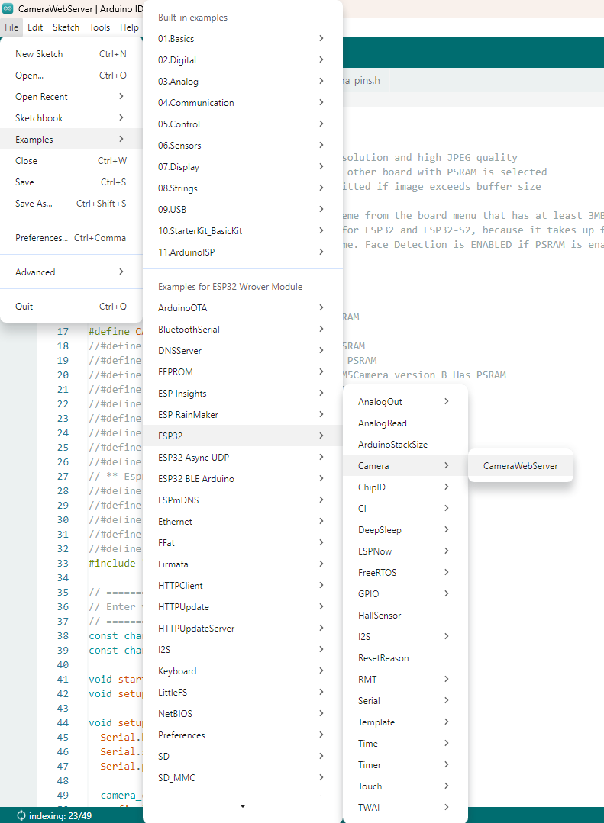
Figure 3 shows the directory of the example in Arduino IDE
- Bridge the IO pin to the GND pin
- Comment the default camera model “CAMERA_MODEL_ESP_EYE” and uncomment the “CAMERA_MODEL_AI_THINKER”
- Insert your SSID and password
- Upload the code
- After uploading is done, the bridge of wire connecting I0 and GND can be disconnected
- Copy the IP address from the Serial Monitor and observe the web

4. Arduino Code Example
The arduino code example is located at Appendix A.

⚠️ Safety Precautions
- Do not power the servo from USB alone — use a 5V 2A source
- Avoid short circuits on the breadboard
- Disconnect IO0 from GND after uploading/flashing code
- Remember to bring an external power supply to power the ESP32 CAM

5. Task

1. Integrate a pushbutton for manual control of servo panning. [Mandatory]
- Modify the existing code (which pans continuously) so that the servo only moves when the button is pressed.
- Connect one leg of the pushbutton to a GPIO pin (e.g., GPIO 13) and the other to GND.
- Use an internal pull-up resistor in software or an external resistor if needed.

2. Use ESP32-CAM face detection capabilities. [Intermediate]
- Modify code so that the servo can follow the face detected on the screen
- Hint: Use the face detection option on the web
- Hint: Use coordinate system to ensure the location of the face detected

6. References
- https://randomnerdtutorials.com/program-upload-code-esp32-cam/
How to Program / Upload Code to ESP32-CAM AI-Thinker (Arduino IDE)
- https://my.cytron.io/p-ch340-usb-to-ttl-serial-cable

CH340 USB to TTL Serial Cable
- https://arduino-er.blogspot.com/2020/09/program-esp32-cam-using-ftdi-adapter.html

Program ESP32-CAM using FTDI adapter
- https://www.youtube.com/watch?v=D3MPBPGT3cw
Program ESP32-CAM using FTDI adapter
- https://core-electronics.com.au/guides/esp32-cam-set-up/
- https://www.youtube.com/watch?v=Y7LWcAwzpPE

Appendix A
#include "esp_camera.h"
#include <WiFi.h>
#define CAMERA_MODEL_AI_THINKER // Has PSRAM
#include "camera_pins.h"

// ===========================
// Enter your WiFi credentials
// ===========================
const char* ssid = "**********";
const char* password = "**********";

void startCameraServer();
void setupLedFlash(int pin);

void setup() {
Serial.begin(115200);
Serial.setDebugOutput(true);
Serial.println();

camera_config_t config;
config.ledc_channel = LEDC_CHANNEL_0;
config.ledc_timer = LEDC_TIMER_0;
config.pin_d0 = Y2_GPIO_NUM;
config.pin_d1 = Y3_GPIO_NUM;
config.pin_d2 = Y4_GPIO_NUM;
config.pin_d3 = Y5_GPIO_NUM;
config.pin_d4 = Y6_GPIO_NUM;
config.pin_d5 = Y7_GPIO_NUM;
config.pin_d6 = Y8_GPIO_NUM;
config.pin_d7 = Y9_GPIO_NUM;
config.pin_xclk = XCLK_GPIO_NUM;
config.pin_pclk = PCLK_GPIO_NUM;
config.pin_vsync = VSYNC_GPIO_NUM;
config.pin_href = HREF_GPIO_NUM;
config.pin_sccb_sda = SIOD_GPIO_NUM;
config.pin_sccb_scl = SIOC_GPIO_NUM;
config.pin_pwdn = PWDN_GPIO_NUM;
config.pin_reset = RESET_GPIO_NUM;
config.xclk_freq_hz = 20000000;
config.frame_size = FRAMESIZE_UXGA;
config.pixel_format = PIXFORMAT_JPEG; // for streaming
//config.pixel_format = PIXFORMAT_RGB565; // for face detection/recognition
config.grab_mode = CAMERA_GRAB_WHEN_EMPTY;
config.fb_location = CAMERA_FB_IN_PSRAM;
config.jpeg_quality = 12;
config.fb_count = 1;

// if PSRAM IC present, init with UXGA resolution and higher JPEG quality
// for larger pre-allocated frame buffer.
if(config.pixel_format == PIXFORMAT_JPEG){
if(psramFound()){
config.jpeg_quality = 10;
config.fb_count = 2;
config.grab_mode = CAMERA_GRAB_LATEST;
} else {
// Limit the frame size when PSRAM is not available
config.frame_size = FRAMESIZE_SVGA;
config.fb_location = CAMERA_FB_IN_DRAM;
}
} else {
// Best option for face detection/recognition
config.frame_size = FRAMESIZE_240X240;
#if CONFIG_IDF_TARGET_ESP32S3
config.fb_count = 2;
#endif
}

#if defined(CAMERA_MODEL_ESP_EYE)
pinMode(13, INPUT_PULLUP);
pinMode(14, INPUT_PULLUP);
#endif

// camera init
esp_err_t err = esp_camera_init(&config);
if (err != ESP_OK) {
Serial.printf("Camera init failed with error 0x%x", err);
return;
}

sensor_t * s = esp_camera_sensor_get();
// initial sensors are flipped vertically and colors are a bit saturated
if (s->id.PID == OV3660_PID) {
s->set_vflip(s, 1); // flip it back
s->set_brightness(s, 1); // up the brightness just a bit
s->set_saturation(s, -2); // lower the saturation
}
// drop down frame size for higher initial frame rate
if(config.pixel_format == PIXFORMAT_JPEG){
s->set_framesize(s, FRAMESIZE_QVGA);
}

#if defined(CAMERA_MODEL_M5STACK_WIDE) || defined(CAMERA_MODEL_M5STACK_ESP32CAM)
s->set_vflip(s, 1);
s->set_hmirror(s, 1);
#endif

#if defined(CAMERA_MODEL_ESP32S3_EYE)
s->set_vflip(s, 1);
#endif

// Setup LED FLash if LED pin is defined in camera_pins.h
#if defined(LED_GPIO_NUM)
setupLedFlash(LED_GPIO_NUM);
#endif

WiFi.begin(ssid, password);
WiFi.setSleep(false);

while (WiFi.status() != WL_CONNECTED) {
delay(500);
Serial.print(".");
}
Serial.println("");
Serial.println("WiFi connected");

startCameraServer();

Serial.print("Camera Ready! Use 'http://");
Serial.print(WiFi.localIP());
Serial.println("' to connect");
}

void loop() {
// Do nothing. Everything is done in another task by the web server
delay(10000);
}

